**1.3.2 - 1.3.6 Notes and Journals**

There are 4 types of data points.

They are integer, floating point, strings, and booleans.

**Integer -** (int) represent integer values.

**Floating Point**  - (float) reprent float point numbers.

**Strings -** (str) strings of characters. Use ‘ ‘

Raw_input gives you back a string

**Boolean -** (bool) - represents a boolean value, only has 2 options.

**Journals**

**1.3.2**

Nicholas Karalis (11/1/17) - 1.3.2

Apart from being confused from the lesson at first, I had a tough time making the program using all the different 1.3.2 components work. My main problem was that the array of different values were not resetting themselves after every frame, resulting in a “snake”-like tail from the player’s movement path. In the end, I figured it out by instead just resetting each single dimensional array, but every multidimensional array.

Example:

Before

LevelA[r] = MLevelA[r] Red Text Is the multidimensional array of variables that

are used to reset the screens number values, or Blue Text

After

LevelA[r][t] = MLevelA[r][t] [r] and [t] are For Loop variables used for ease of determining

which array to reference and assign

Ben Krueger (11/3/17)

When we started this lesson, I wanted to run the code that was in the lesson. Because we didn’t have an IPython session, it didn’t work. To try to get around this problem, we tried to use the solution Mr. Greenway gave us. We tried to access juniper notebook. To use it, we had to download anaconda software. In that software we were able to access juniper notebook, but the notebook didn’t have any terminals, so we could not use it. We just tried to show using an import and variables with other commands.

John McCarthy (11-3-17)

Like ben i was trying to run the code listed in the lesson. We didn't have an interactive command running prompt. So, we tried to find one. I downloaded anaconda and attempted to use jupyter but didn't know what or how to do anything in it. I theorise that a .py program can be opened and ran, but i'm not sure. I researched how to change color in pythons terminal and found a module called curses so Nick is now using that for the game we are making for 1.3.2.

Aidan MacDonell (11/3/17)

(We) are currently working on a game where you are a one and are blocked by twos. You have move around the twos to get to your goal. We had a problem with this because the grid was off by one therefore the movement system is all screwed up and none of the twos were in the right spot. We are still working on fixing this and we are researching on the forums to see if we can find any solutions.

Devin Patel (11/3/17)-1.3.2

IF you enter 5 + 3 into the code it won’t answer nor if you put in the input or output statements. You have to enter it in as a variable. Then when you finish that, you will have to say print the variable itself and it will show the answer. When you multiply the variables by a number, it doesn’t change the number. You have to multiply the variable inside the variable. So you have to type in the variable then equals to change the variable at all. Then you have to do the variable again then multiply or change it however you want to make it a different value. Then print the variable to show it in the code at the end when you run it. I tried to find the absolute value of the number -21 but it still showed -21. Abs is the command for absolute value. I tried again with no space in between the () and the command but it didn’t work.

**1.3.3**

Nicholas Karalis (11/7/17) - 1.3.3

The overall lesson was very simple to learn and understand. Also, implementing these concepts into our python project was also very easy, as most of it is essential for making a program and therefore would already be there from the start. Some problems I would say we had were that when adding branching to our project (if, if-else, else-if, for loop, etc) we would sometimes screw up the conditions in order for that code to run, however it is usually a simple mistake with a simple fix.

Ben Krueger (11/7/17) - 1.3.3

For this lesson we had to add if - statement into our program. In scratch, the if - block was yellow and there was also the if else block. In python, they work much in the same way. You state the scenario, then under that you include what to do if it its true. The small piece of code above, picks either 1 or 0 and sets that to the number variable. Then, if the number is one, it prints that the number is one and if the number is zero, it prints that the number is 0. One difficulty I had when writing this code was a syntax error. After the if statement and the else, statement, you have to add a colon, to have a proper syntax.

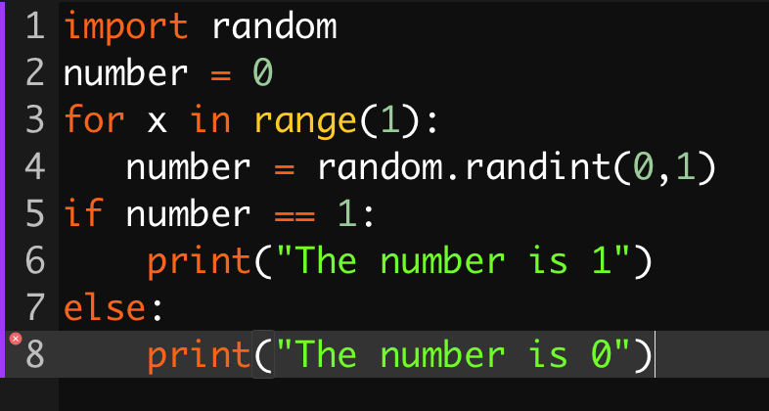

**1.3.4 - Ben Krueger**

In this lesson I learned about nested if statements. You can make an if statement inside of an if statement. To demonstrate this concept, I am currently developing a game where the computer guesses a number you are thinking of. One struggle I had while creating this game was that I forgot to set the inputs to a variable. The code just broke off, but after I set it to a variable, it worked.

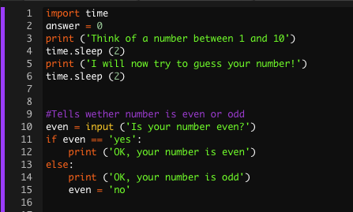

**1.3.4**

Nicholas Karalis (11/7/17) - 1.3.4

I’ve worked with Casting variables and conditional indenting since I first worked with coding. All the concepts are easy to understand. However, casting can be confusing when switching from different languages, as with any non general commands.

**1.3.5**

Aidan MacDonell (11/8/17) 1.3.5

1.3.5 was all about strings. Strings and integers aren't very confusing however it gets very annoying when you have to constantly change the integers to a string and back. You can also slice strings and find the indexes within. To do this you use two brackets and two numbers separated by a colon in the middle. This allows you to take out certain indexes that are in the middle of your string.



**1.3.6**

Nicholas Karalis (11/8/17)-1.3.6

Throughout my entire programming ‘career’ I’ve never heard of tuples. Now that I have, it’ll hopefully make my programs run faster because of its supposed lack of memory usage. A problem I had when making my example program (I have lists in my main program, however I did not think I would have time to implement tuples into it) was making a tuple and list work together to make a message. I at first wanted to implement time and different functions into the program but soon found out that I over complicated things and everything could be simplified with a single For Loop. Here is my result.

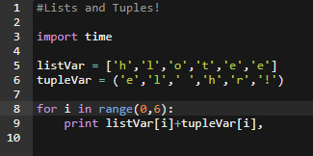

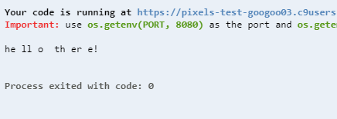

**1.3.7**

John McCarthy



This is a for loop, this is called a for loop because it loops through the array and does an action “for” every value in the array. This for loop prints the values squared.

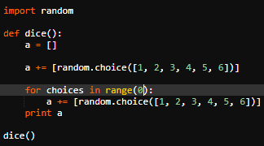

This is a code for a dice roller of a d6.



When the code is ran it pops out a random whole number between 1 and 6.

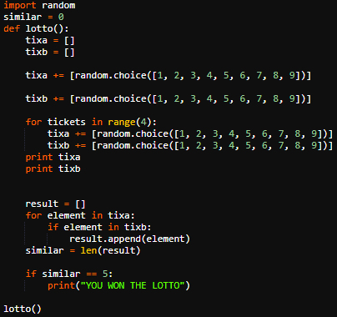

For the final program in the 1.3.7 PLTW Notes i made a lottery system that would make two random numbers and compare them, if they shared 5 numbers you won the lottery. I used a two for loops, one for the 5 ticket numbers and one to get the similar values of the two tickets.



This is the input of a loss in a lottery run. I had to artificially win because winning the 5 number lotto is a 1 in a 240 chance of winning.

**Conclusion:**

Sometimes code using an iterative loop can be written without a loop, simply repeating the iterated code over and over as separate lines in the program. Explain the disadvantages of developing a program this way.

The disadvantages of repeating iterative code is that it takes longer to load during the game and with a for loop you can write all of those checks and tweaks in one bundle of code instead of strands of the same code over and over.

Name a large collection across which you might iterate.

If you are finding the amount of people living in each household in the united states, you're not going to write millions of lines of code, you can just write a loop and have it loop millions of times.

What is the relationship between iteration and the analysis of a large set of data?

To analyse you need to have data to analyse, iteration provides a visual for that data.

**1.3.8**

Nicholas Karalis (11/14/17)

To me, I have a pretty good understanding of what while loops are, as I use for loops quite often. However, the syntax I get confused with, and still need to learn how I can integrate the loops into our future projects. I made an example in cloud9 to get a sense of familiarity of while loops.

